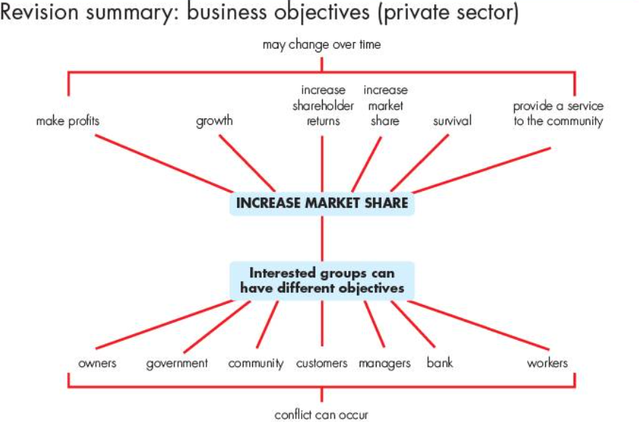

The stakeholders in businesses have different objectives and businesses have to try to meet all these objectives. Below is a diagram of the objectives of the different groups. Sometimes these objectives can clash and be in conflict.

