Exam Style Question:
Organisation and Management

Question 1.
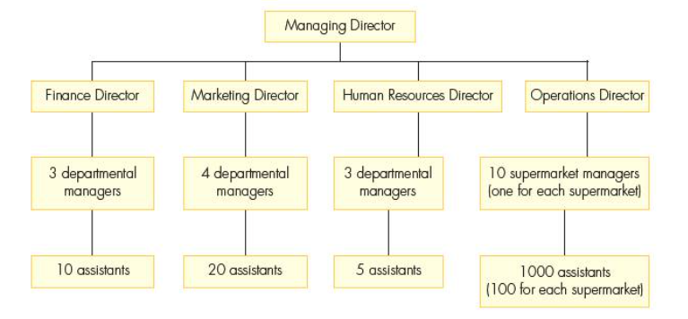

- Define ‘hierarchical structure’.
______________________________________________________________________________________________________________________________________________ [2 marks]

- Identify the span of control for the:
Operations Director
___________________________________________________________________________
Finance Director
___________________________________________________________________ [2 marks]

- Outline two functions of the Managing Director.
Function 1:
____________________________________________________________________________________________________________________________________________________________________________________________________________________________________________________________________________________________________________
Function 2:
____________________________________________________________________________________________________________________________________________________________________________________________________________________________________________________________________________________________________ [4 marks]

- Explain two disadvantages to this business for having a tall organisational structure.
Disadvantage 1:
__________________________________________________________________________________________________________________________________________________________________________________________________________________________________________________________________________________________________________________________________________________________________________________________________________________________________________________________________
Disadvantage 2:
__________________________________________________________________________________________________________________________________________________________________________________________________________________________________________________________________________________________________________________________________________________________________________________________________________________________________________________________ [6 marks]

- Do you think more delegation would be a good idea for this business? Justify your answer.
__________________________________________________________________________________________________________________________________________________________________________________________________________________________________________________________________________________________________________________________________________________________________________________________________________________________________________________________________
_____________________________________________________________________________________________________________________________________________________________________________________________________________________________________________________________________________________________________________________________________________________________________________________________________________________________________________________________________________________________________________________________________ [6 marks]

Question 2. Read the insert for this question

Consider how the following three economies of scale might benefit Peter’s business. Which economy of scale is like to have the biggest effect on profits? Justify your answer.

Purchasing:
_______________________________________________________________________________________________________________________________________________________________________________________________________________________________________________________________________________________________________________________________________________________________________________________

Technical:
_______________________________________________________________________________________________________________________________________________________________________________________________________________________________________________________________________________________________________________________________________________________________________________________

Financial:
_______________________________________________________________________________________________________________________________________________________________________________________________________________________________________________________________________________________________________________________________________________________________________________________

Conclusion:
_______________________________________________________________________________________________________________________________________________________________________________________________________________________________________________________________________________________________________________________________________________________________________________________
________________________________________________________________________________________________________________________________________________________________________________________________________________________ [12 marks]

